***Chemistry***

**12: Kinetics**

**12.4: Integrated Rate Laws**

33. Use the data provided to graphically determine the order and rate constant of the following reaction:

|  |  |  |  |  |  |  |  |
| --- | --- | --- | --- | --- | --- | --- | --- |
| Time (s) | 0 | 5.00 × 103 | 1.00 × 104 | 1.50 × 104 | 2.50 × 104 | 3.00 × 104 | 4.00 × 104 |
| [SO2Cl2] (*M*) | 0.100 | 0.0896 | 0.0802 | 0.0719 | 0.0577 | 0.0517 | 0.0415 |

Solution

Plotting a graph of ln[SO2Cl2] versus *t* reveals a linear trend; therefore we know this is a first-order reaction:

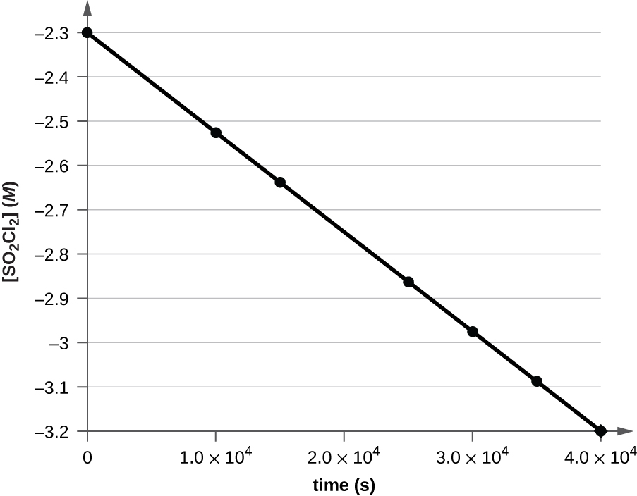

The value of *k* is found from the slope of the line since  is in the form of a straight line, *y* = *mx* + *b*.



Since rate constants are by convention positive, *k* for this reaction should be reported as 2.20 × 10–5 s–1.

35. Pure ozone decomposes slowly to oxygen, . Use the data provided in a graphical method and determine the order and rate constant of the reaction.

|  |  |  |  |  |
| --- | --- | --- | --- | --- |
| Time (h) | 0 | 2.0  103 | 7.6  103 | 1.00  104 |
| [O3] (*M*) | 1.00  10–5 | 4.98  10–6 | 2.07  10–6 | 1.66  10–6 |
| Time (h) | 1.23  104 | 1.43  104 | 1.70  104 |  |
| [O3] (*M*) | 1.39  10–6 | 1.22  10–6 | 1.05  10–6 |  |

Solution

To distinguish a first-order reaction from a second-order reaction, we plot ln[*P*] against *t* and compare that plot with a plot of  versus *t*. The values needed for these plots are abbreviated to include only the data needed for a second-order plot, as the data do not seem to support a first-order reaction:

|  |  |  |  |  |  |  |  |
| --- | --- | --- | --- | --- | --- | --- | --- |
|  | 1.00  105 | 2.01  105 | 4.83  105 | 6.02  105 | 7.19  105 | 8.20  105 | 9.52  105 |

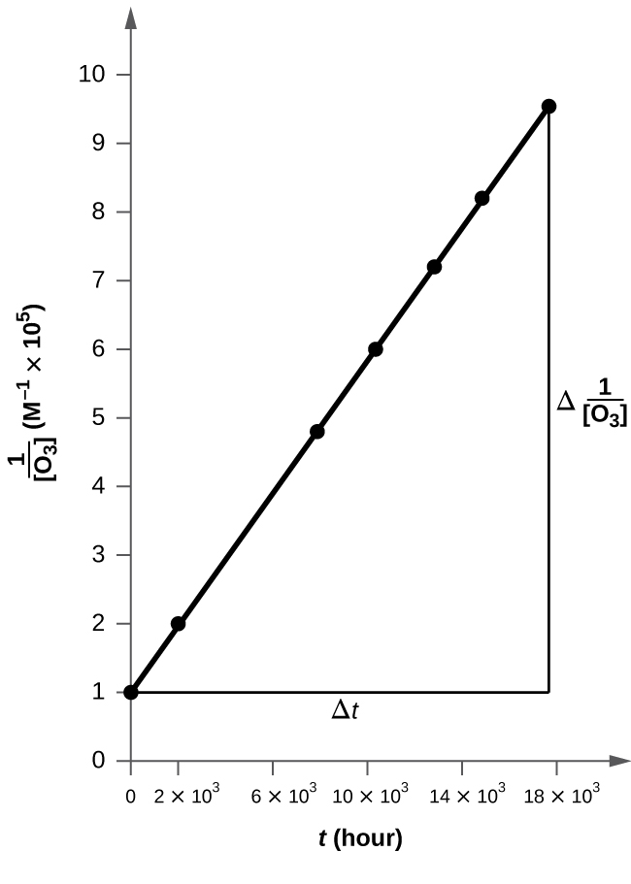

The plot is nicely linear, so the reaction is second order.



37. What is the half-life for the first-order decay of phosphorus–32? The rate constant for the decay is 4.85  10−2 day−1.

Solution

The half-life is , where *k* is the rate constant:





39. What is the half-life for the decomposition of NOCl when the concentration of NOCl is 0.15 *M*? The rate constant for this second-order reaction is 8.0  10–8 L/mol/s.

Solution

In a second-order reaction, the rate is concentration-dependent, .



41. The reaction of compound *A* to give compounds *C* and *D* was found to be second-order in *A*. The rate constant for the reaction was determined to be 2.42 L/mol/s. If the initial concentration is 0.500 mol/L, what is the value of t1/2?

Solution

For a second-order reaction, the half-life is concentration-dependent:



43. Some bacteria are resistant to the antibiotic penicillin because they produce penicillinase, an enzyme with a molecular weight of 3  104 g/mol that converts penicillin into inactive molecules. Although the kinetics of enzyme-catalyzed reactions can be complex, at low concentrations this reaction can be described by a rate equation that is first order in the catalyst (penicillinase) and that also involves the concentration of penicillin. From the following data: 1.0 L of a solution containing 0.15 μg (0.15  10−6 g) of penicillinase, determine the order of the reaction with respect to penicillin and the value of the rate constant.

|  |  |
| --- | --- |
| [Penicillin] (*M*) | Rate (mol/L/min) |
| 2.0  10−6 | 1.0  10−10 |
| 3.0  10−6 | 1.5  10−10 |
| 4.0  10−6 | 2.0  10−10 |

Solution

The reaction is first order with respect to penicillinase, and the rate doubles as [penicillin] doubles. Thus the rate equation is:

rate = *k*[penicillinase][penicillin]

Using the data in the first row,



45. There are two molecules with the formula C3H6. Propene, , is the monomer of the polymer polypropylene, which is used for indoor-outdoor carpets. Cyclopropane is used as an anesthetic:

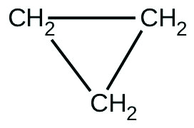

When heated to 499 °C, cyclopropane rearranges (isomerizes) and forms propene with a rate constant of 5.95 × 10–4 s–1. What is the half-life of this reaction? What fraction of the cyclopropane remains after 0.75 h at 499 °C?

Solution

The provided rate constant’s unit is s–1, indicating the reaction is first-order, and so



The fraction remaining after 0.75 h may be determined from the integrated rate law:



Rearranging this equation to isolate the fraction remaining yields



Converting the time to seconds and substituting values for *k* and *t* gives



And so, 20% of the reactant remains.

47. Suppose that the half-life of steroids taken by an athlete is 42 days. Assuming that the steroids biodegrade by a first-order process, how long would it take for  of the initial dose to remain in the athlete’s body?

Solution

 where *x* represents the number of half-life periods *x* = 6, so (6)(42) = 252 days.

49. Nitroglycerine is an extremely sensitive explosive. In a series of carefully controlled experiments, samples of the explosive were heated to 160 °C and their first-order decomposition studied. Determine the average rate constants for each experiment using the following data:

|  |  |  |  |  |  |  |  |  |
| --- | --- | --- | --- | --- | --- | --- | --- | --- |
| Initial [C3H5N3O9] (*M*) | 4.88 | 3.52 | 2.29 | 1.81 | 5.33 | 4.05 | 2.95 | 1.72 |
| *t* (s) | 300 | 300 | 300 | 300 | 180 | 180 | 180 | 180 |
| % Decomposed | 52.0 | 52.9 | 53.2 | 53.9 | 34.6 | 35.9 | 36.0 | 35.4 |

Solution

From the first-order rate law, calculate the value of [*A*], , and *k*. The values are tabulated:

|  |  |  |  |  |
| --- | --- | --- | --- | --- |
| [*A*]0 (*M*) | [*A*] (*M*) |  | *t* (s) | *k* × 103 (s–1) |
| 4.88 | 2.34 | 0.734 | 300 | 2.45 |
| 3.52 | 1.66 | 0.752 | 300 | 2.51 |
| 2.29 | 1.07 | 0.761 | 300 | 2.53 |
| 1.81 | 0.834 | 0.775 | 300 | 2.58 |
| 5.33 | 3.49 | 0.423 | 180 | 2.36 |
| 4.05 | 2.61 | 0.439 | 180 | 2.47 |
| 2.95 | 1.89 | 0.445 | 180 | 2.48 |
| 1.72 | 1.11 | 0.438 | 180 | 2.43 |

This resource file is copyright 2015, Rice University. All Rights Reserved.